**PR4/PR5 REDO**

*Design Justifications: Breda Bread*

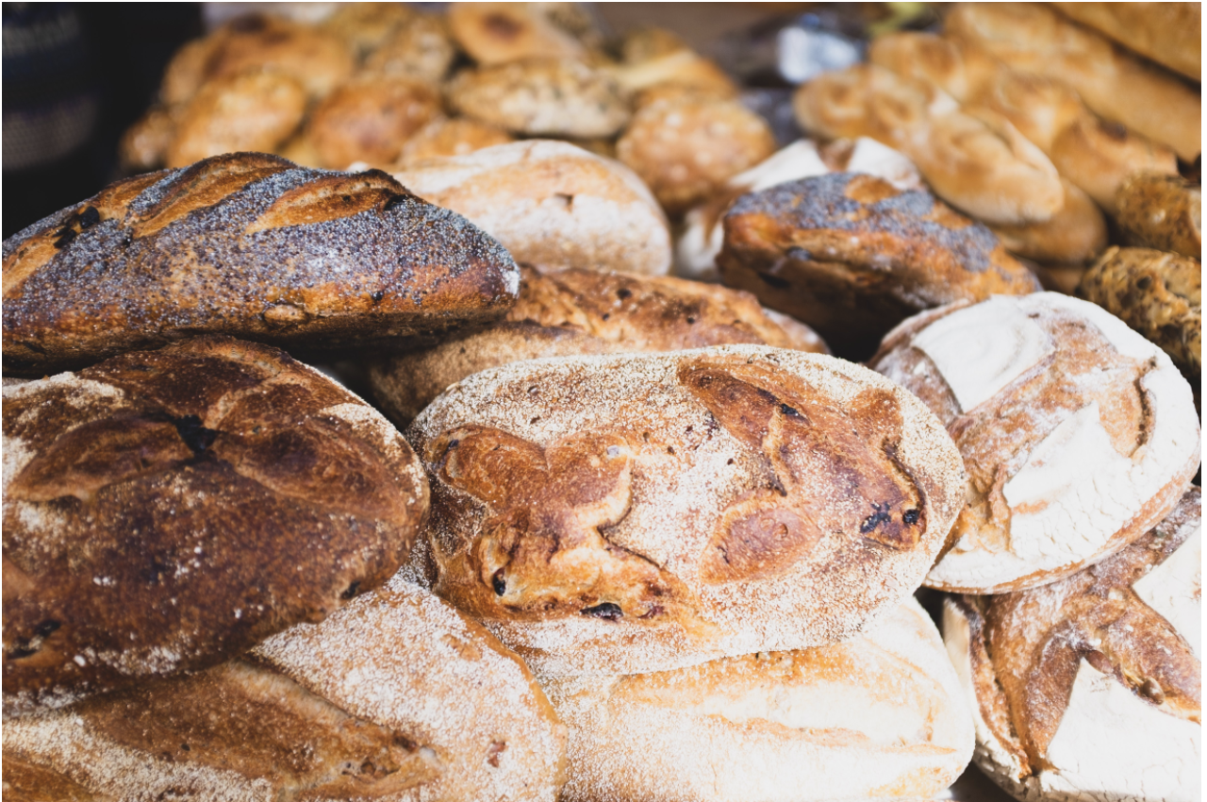

A document made by: Daphne Sieffers (172703)

Maggie Stoker (160328)

Tessa Hoorn (170767)

Lisenka Velderman (172959)

# Table of Contents

Wireframes 3

Flow diagram 6

Paper Prototypes 7

Colour codes 9

Fonts 9

Images 9

6. User testing 10

# 

# 

# 

# **Wireframes**

When we started we came up with several options of how our website could look, below you can find the first wireframes we came up with.

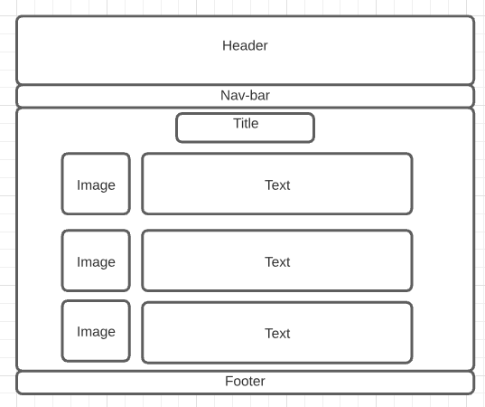 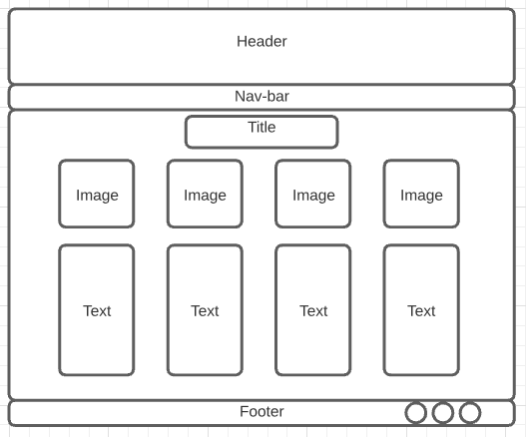

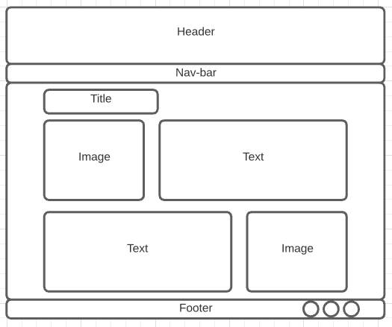 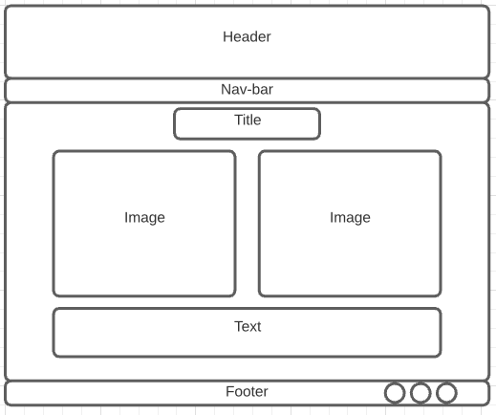

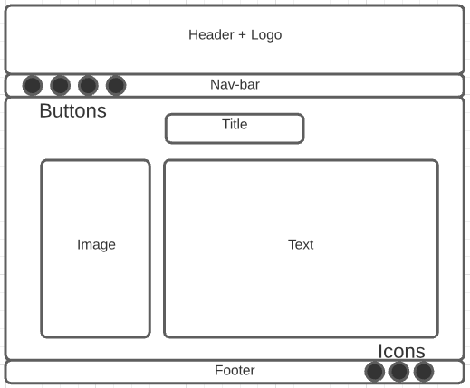 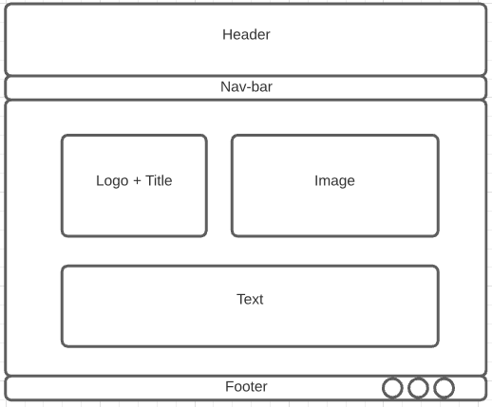

Eventually we picked a simple wireframe for the homepage:

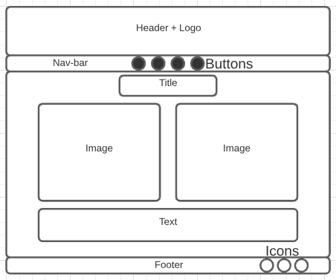

We started making our site based on this homepage wireframe. While developing the website we only changed minor things; added logo, phone number, mail to the footer and added our slogan below the logo in the header. The rest of the wireframe remained unchanged.

We later used elements we liked from or different wireframes we started off with to organise the other webpages. We made paper prototypes for these that can be found back in Chapter 3: Paper Prototypes.

# **Flow diagram**

This flow diagram describes the structure and navigation of our website. We decided to keep the navigation workflow simple and use our nav-bar to easily guide our website visitors through our website. The social media icons in our footer are functioning and guide you to the actual social media platform, in reality this would be the company’s social media page.

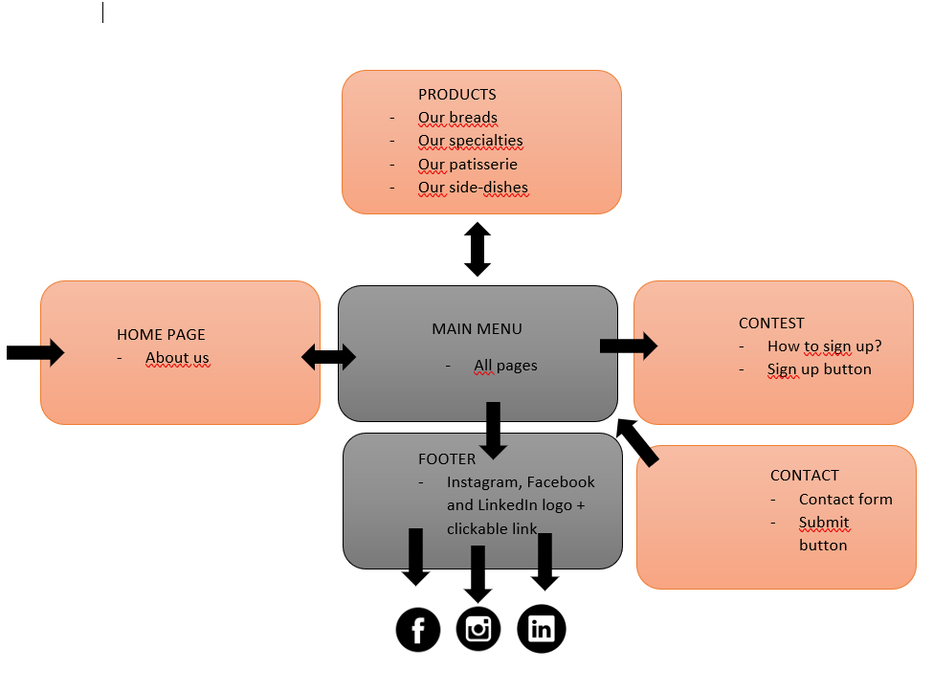

# **Paper Prototypes**

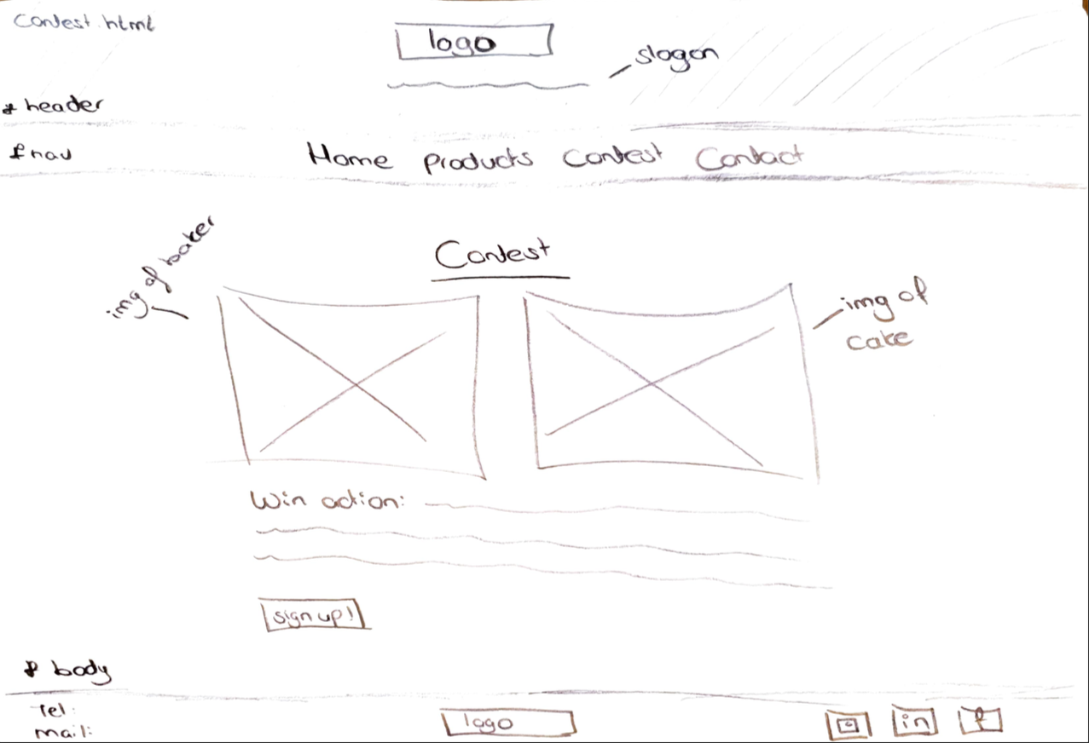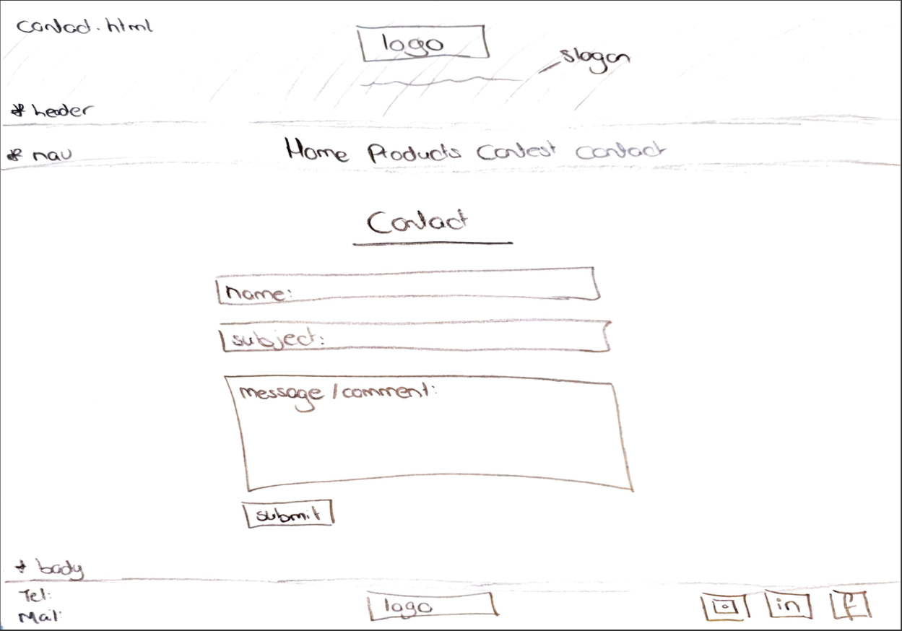

# **Colour codes**

The colours + colour codes that we have used are:

Red; 811000

The red we chose has a beautiful contrast with

Black; 000000

The logo which we had to work with was mostly black hence it is included in our colour pallet.

Orange; (insert colour code)

This colour matches well with the colour of the freshly baked breads we showcase on our website.

Light Brown; e3a36d

This colour matches well with the colour of the freshly baked breads we showcase on our website. Which is also why we showcase this colour in our header.

Antraciet; 202529

We chose to use this colour for our text, we found black to be a little too harsh and chose a dark shade of gray instead.

# **Fonts**

Fonts which we have used are

* Roboto Slab - for headers and titles
* Montserrat - for paragraphs

These fonts fit our target audience and we found these fonts to be the most professional and readable when applied to our website.

# **Images**

The images that we have used come from Pexels and Unsplash. These websites both offer good quality pictures, a large range in subjects and copyright free use. When we first started looking, we tried to focus ourselves on showing our target audience the right look and feel of Breda Bread itself. After having talked about the colours that we wanted to use, we came to the conclusion that for the images we also wanted to showcase a professional and delicious look and feel.

The images that we eventually chose all have a black, brown or dark gray background, which makes them beautifully contrasting with the red colour that we are using in other components of our website.

# **6. User testing**

**Evidence of testing**

Our website was tested by friends and family, in total we had 7 people who tested our website for us.

While they tested our website we gave them one of the following tasks such as;

* Sign up for our company’s contest
* Navigate to our specialties
* Navigate to our side-dishes
* Navigate to our Facebook page
* Ask us what a question through the website (So do not use our company’s phone number or email)

After they succeeded in their task we asked them to return to the homepage, this was done to test the error tolerance. When someone clicks on a wrong button he/she needs to easily be able to return to the previous page or homepage.

**Outcomes of testing**

After the User Test we were able to conclude;

Our website seemed to be ***effective*** as all participants were able to obtain their goal.

Our website seemed to be ***efficient*** as all participants achieved their goals quickly without complications.

Our website seemed to be ***engaging*** as all participants found our colour pallet stylish and our website pleasant.

Our website seemed to be ***error tolerant*** as all participants can easily redirect themselves to the homepage when asked. Meaning when they click on a wrong button or make an error they are able to backtrack and go to their right destination on the website.

**Improvements (even checke of deze improvement ook uitgevoerd hadden moette worden na User Test)**

We got feedback from one of our participants who tested the website. She said it was nice we had the company’s phone number and email on every page (in the footer). However, she was of the opinion it should also be displayed on the contact page (besides the footer on the contact page). She pointed out it would be nice to have the following things clarified on a contact page;

* Phone number paired with opening hours, so visitors of our website know when they can reach the shop.
* Email
* Address
* The name of our facebook page and other social media pages

We agree with her feedback

**Own Improvements**

Our own improvements for the website based on the user testing is adding a ‘Search bar’ in the nav-bar. This way if someone would not be able to easily find their way to their destination on our website they could always use the search bar.